Name : Fissha Fatima

Site-to-Site IPsec VPN

Objective
To design and implement a secure Site-to-Site IPsec VPN between two remote LANs over an untrusted network using Cisco Packet Tracer. The goal is to protect the data transmission between two locations using encryption and authentication mechanisms.
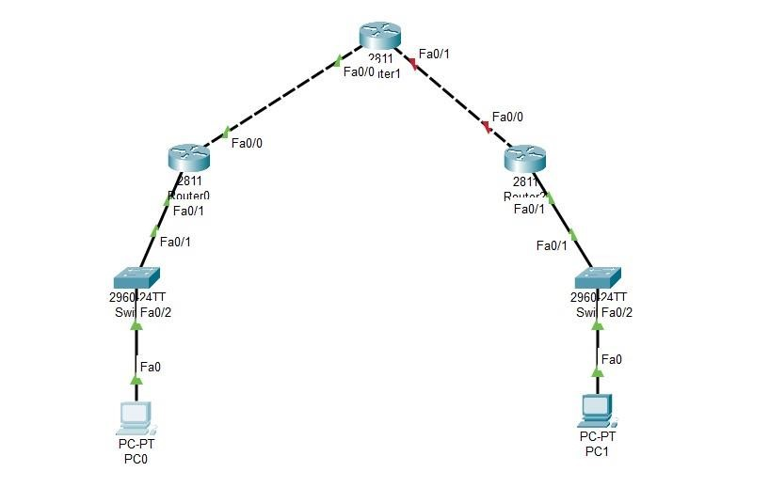
Implementation Steps Step 1:

Configure Router Interfaces
IP addresses were assigned based on the IP scheme and tested using ping. Ensure all routers (R1, R2, R3) have proper IP address like 192.X.X.X configurations and can ping each other’s interfaces.

Step 2: Configure Routing (RIP v2)
RIP routing protocol was used to enable reachability between LANs across routers.Implement dynamic routing so that R1 and R3 can reach each other’s LAN networks.
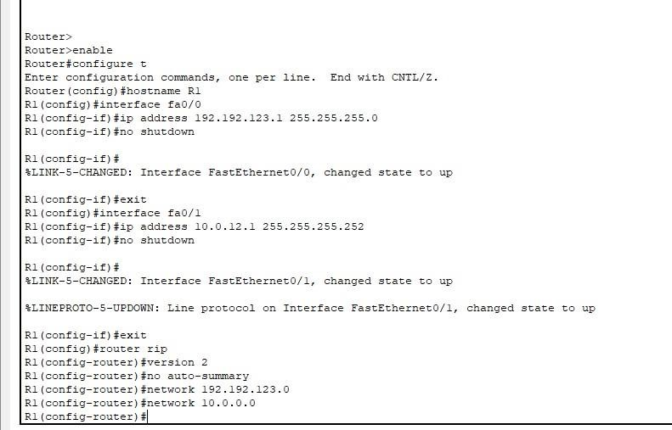
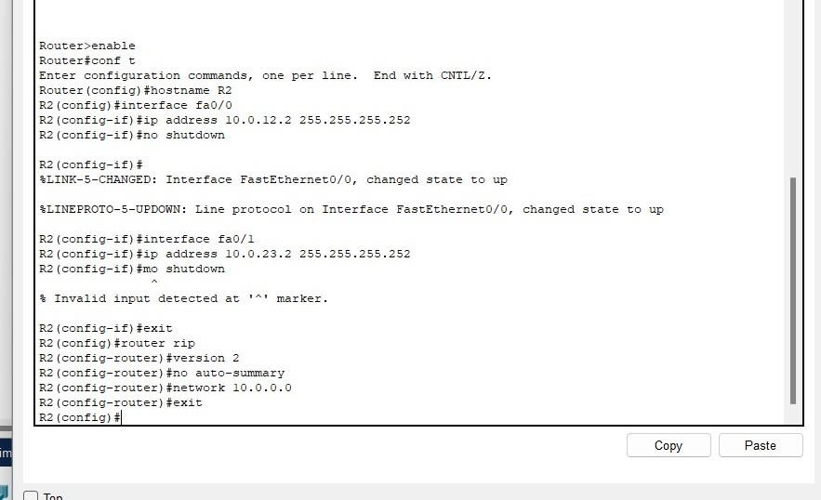
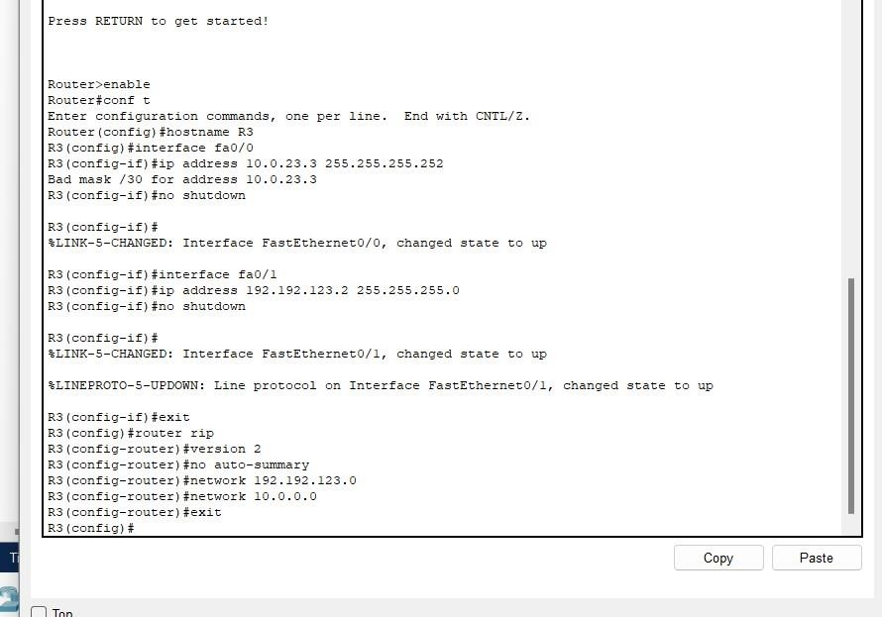

Step 3: Configure ISAKMP Phase 1
Policy included AES 256 encryption, SHA hashing, DH Group 5, pre-shared key ("Haiqa"), and lifetime 86400 seconds. On R1 and R3, configure ISAKMP with AES 256 encryption, SHA hashing, pre-shared key, DH Group 5, and 86400 sec lifetime.
Step 4: Set Pre-shared Key
Shared key was set on R1 and R3 using peer IP addresses.
Isakmp phase 1 policy on r1 and r3
R1
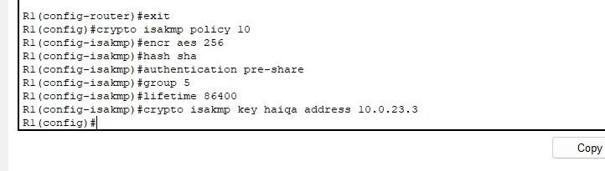

R3
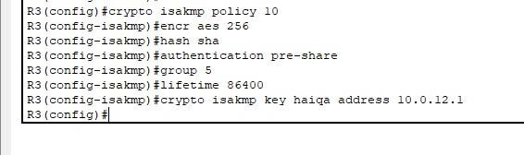

Step 5: Define Interesting Traffic (ACL)
ACLs on both R1 and R3 were created to match LAN-to-LAN IP ranges to trigger VPN. Create access control lists to define which traffic should be encrypted between R1 and R3 LANs. R1
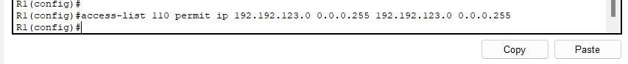

R3

Step 6: Configure IPsec Phase 2
A transform set using ESP with AES 256 and SHA for integrity was configured.Use ESP with AES 256 encryption and SHA for integrity in a transform set.

Ipsec phase 2 transform set R1

R3

Step 7: Crypto Map Configuration
Crypto maps were created to bind the transform set, peer IP, and ACL. Bind the transform set and peer IP to a crypto map and apply it to the outgoing interface on both R1 and R3. R1
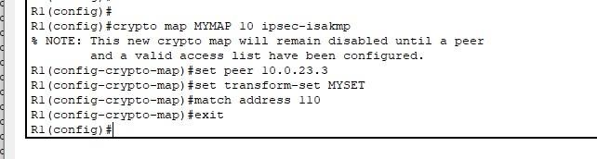

R3
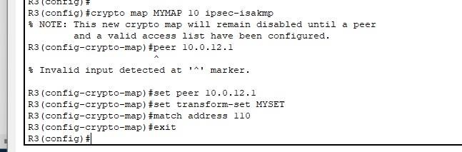

Step 8: Apply Crypto Map to Interfaces
Crypto maps were applied to the public-facing interfaces (R1 to R2 and R3 to R2). R1
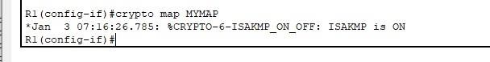

R3
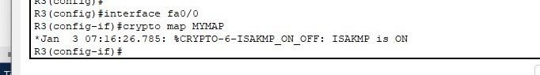

Step 9: Test VPN Tunnel
Ping from PC1 to PC2 initiated the VPN tunnel.
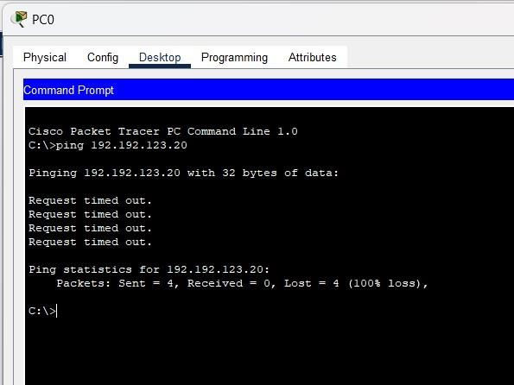
Step 10: Verify Tunnel Status Commands used:
- show crypto isakmp sa
- show crypto ipsec sa
Tunnel was confirmed up with state QM_IDLE and active encrypted packet counts. R1
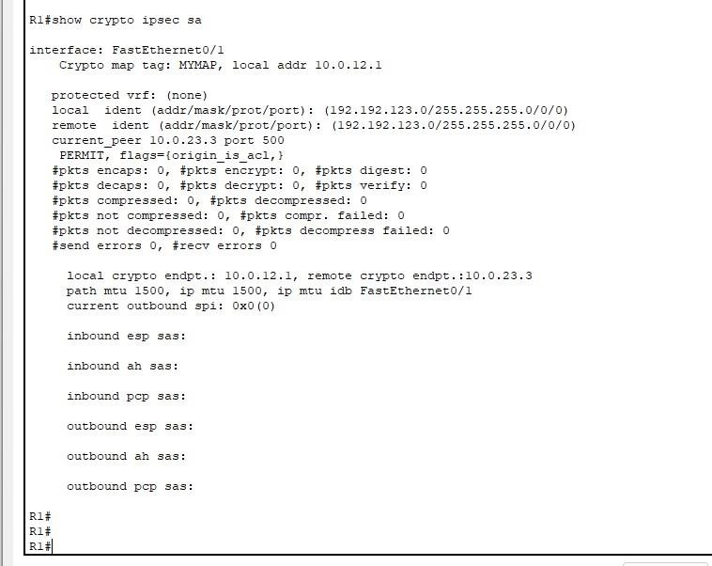 R3
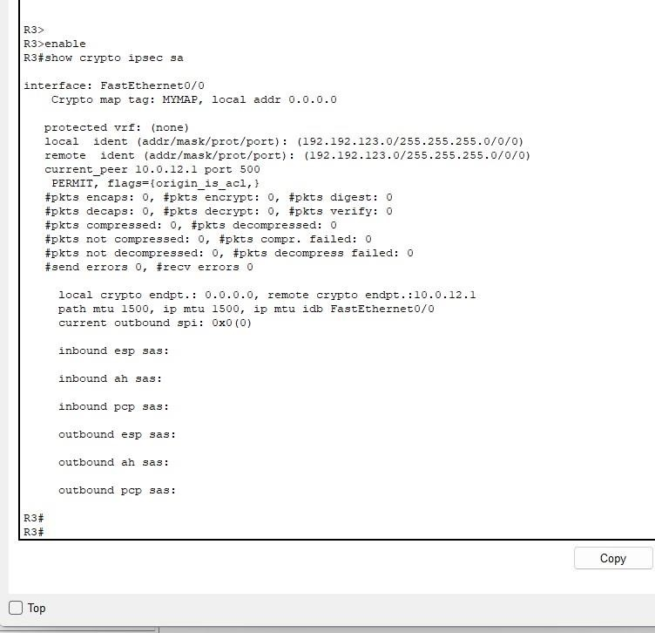

Observations and Results
- VPN tunnel was successfully established.
- Encrypted and decrypted packet counters increased on both R1 and R3.
- Ping between PC1 and PC2 was successful only after VPN came up.
- Tunnel remained active as long as interesting traffic persisted.

Conclusion
This lab demonstrated the successful setup of a Site-to-Site VPN using IPsec with ISAKMP for secure communication between two remote networks. It emphasized real-world practices of using access lists, transform sets, crypto maps, and peer authentication.

